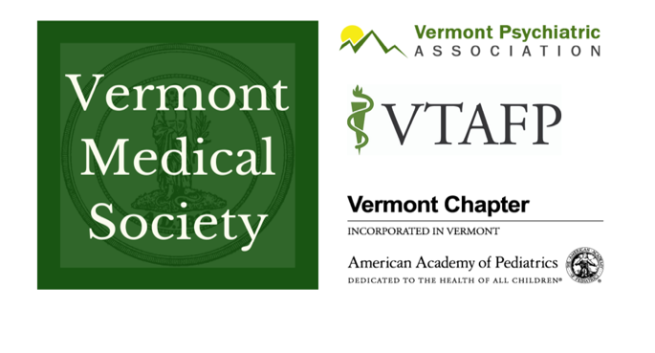
To: | Senate Appropriations Committee
From: | Jessa Barnard on behalf of:  VMS, AAPVT, VTAFP & VPA
When: | April 5, 2022
RE: | Primary Care Loan Repayment Program

Please Restore Funding for AHEC Primary Care Loan Repayment

On behalf of the 2,600 members of the Vermont Medical Society, American Academy of Pediatrics Vermont Chapter, Vermont Academy of Family Physicians, and the Vermont Psychiatric Association we urge the legislature to devote $793,000 to restore the AHEC primary care loan repayment program to 2009 funding levels.

This funding should be dedicated to closing gaps in the current programs for loan repayment to primary care providers at employment sites not otherwise eligible for federal funding and/or increasing the loan repayment amount per recipient.

At a time when Vermont should be investing more in primary care, we are losing ground and no longer competitive with loan repayment programs in neighboring states. With the median education debt for medical school graduates in 2019 equaling approximately $200,000, even those medical students who know they want to practice in Vermont are often driven to states where they receive a more substantial benefit.
Why Investment in Primary Care Loan Repayment is Needed Now!
“I am in an 8-provider practice with 6 current providers, two of whom are trying to retire. We are constantly juggling poor access and caring for several thousand “extra” patients within the practice. Some providers’ panels have ballooned to around 2000 patients, which is untenable. I typically work four 11-hour days with one day of off-site administrative work and am on-call 24/7 for a week about every 6 weeks which is frankly not sustainable. We have had several potential recruits express concern about lower-than-average salaries and loan burdens and have been unable to attract new providers. The absence of loan repayment will not deter me from this work, but its presence would go a long way in making me feel valued for the time and money I have put into my work and community.” - Rachel La Rocca, MD, ABFM, Central Vermont Medical Center (click here for full comments)
Instead of increasing support, over time, the funding for Vermont AHEC's Educational Loan Repayment Program has been drastically reduced to a current rate of $667,111 from a high in FY2009, when it was provided $1,460,000. The Vermont Legislature has made workforce development a major priority this session and developed a number of new initiatives to bolster Vermont's health care workforce yet, has not provided any additional funding for Vermont's Area Health Education Center's (AHEC) Loan Repayment Program.

The chart below shows current loan repayment rates across all New England states:

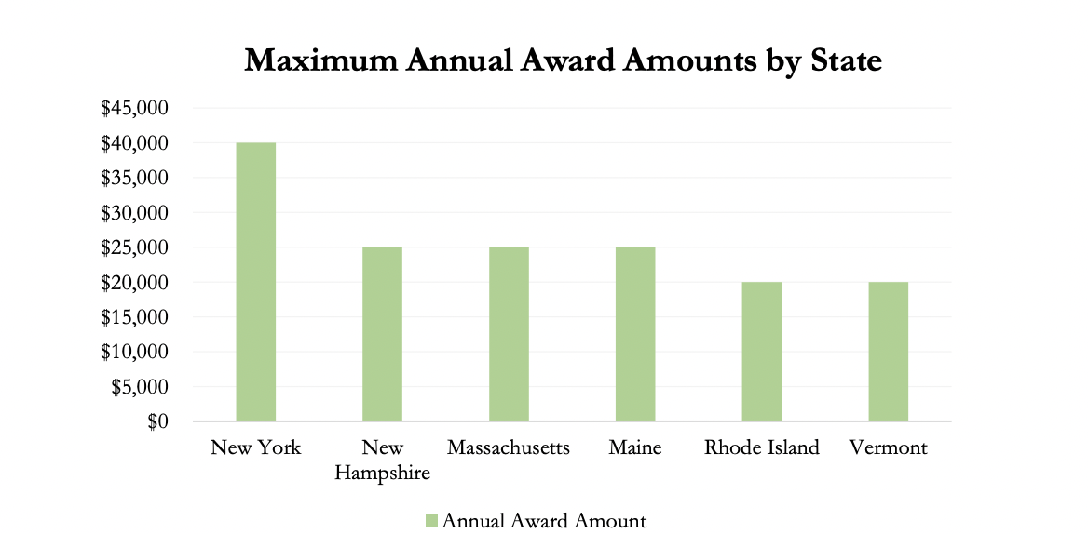
AHEC’s Loan Repayment program is highly competitive and limited, with only 59% of applicants receiving awards in 2019. The Rural Health Workforce Report, from January, 2020, found that Vermont’s stagnant loan repayment funding not only limits the number of unique awards granted each year, but also stunts the value of each loan repayment award. Vermont’s total maximum award to physicians is $20,000/year for up to two years, which ranks near the bottom when compared to other Northeastern states.

“There are precious few primary care graduates coming out of medical training and they have many other options for their employment. We will never prevail in bringing them here without a robust loan repayment program…Please do not underestimate the critical value of AHEC’s program to continue our rural healthcare system and sustain Vermont’s communities. We cannot do it without you.” – Melissa Volansky, MD, Family Medicine, Chief Medical Officer, Lamoille Health Partners (click here for full comments)

The Rural Health Workforce Report also articulated key factors that continue to drive Vermont’s health care workforce crisis, that could be alleviated by a significant increase in loan repayment:

- A Tight National and Local Labor Market – Primary care physicians, coming out of residency with high debt, compare job opportunities across the country.
- Aging workforce – Vermont’s health care workforce is aging: 36% of primary care physicians are over age 60, 25% of primary care ARPNs are over age 60.
- Provider burnout – Even before COVID-19, more than 50 percent of clinicians treating patients reported that they had experienced symptoms of burnout.
“Primary care providers who are well trained are CRUCIAL to the functioning of our health care system and recruiting and retaining them should be one of the TOP priorities of this and every budget going forward, if we want to have the best access and outcomes for Vermonters. As a member of the Primary Cared Advisory Group to the GMCB, I can tell you that this has been one of our top priorities as we discuss ways to ensure access to healthcare.” – Valerie A Rooney, MD FAAP, Brattleboro Memorial Hospital (click here for full comments)

Physician Education Debt and the Cost to Attend Medical School, Association of American Medical Colleges, October 2020
https://gmcboard.vermont.gov/sites/gmcb/files/documents/Rural%20Health%20Services%20Report-%20Workforce%20White%20Paper%20FINAL%201.23.20.pdf

